Title
A. Firstauthor ¹, A. B. Secondauthor ^{1,2}, C. Thirdauthor ³
¹ Affiliation Firstauthor
² Affiliation Secondauthor
³ Affiliation Thirdauthor

This is a sample abstract for the Molecular Electronic Structure (MES 2024) conference in Pescara, Italy.
All interested participants are invited to present the latest results of their scientific work in one of the topics of MES 2024 Conference. The deadline for abstract submission for contributed talks is June 15, 2024 and for posters is September 10, 2024. The preparation instructions are given below.
1. Abstracts should be written in English. The length of each abstract is strictly limited to one page. The authors are responsible for both the content and style of their contributions.
2. The abstract should be one page long, two-column format. We kindly request you to respect the formatting and typesetting of this template, as well as the bibliography style [1]. The font for the main text is Times New Roman (size 10). A template for the abstract in docx format is available for download.
3. Only one figure (Fig. 1) is allowed.

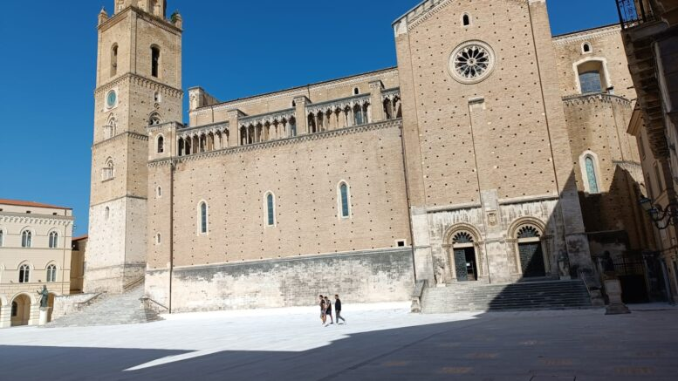
Fig. 1: Figure caption text. Chieti (destination of the excursion), main square.
4. Your abstract must be submitted through the conference website
https://www.mes2024.it/abstract-submission/
specifying the contribution type (invited, contributed oral or poster presentation). Acceptance of contributed oral presentations will be communicated before July 1.
5. The acceptance procedure is considered complete only when the submitting author is registered at the conference through the website:
https://www.mes2024.it/registration/

References
- A. Author, B. Author, etc., scientific journal, volume, page (year).

email presenting author

